Recommendations/Announcements Formatting Guidelines and Template

Proposal title (lower case, Times New Roman 14 points, bold)

Name Surname
Property - Profession and Institution
email@email.gr
(If there are more than one author, list all the names first and then the other details, according to the model:
First Name Last Name¹, First Name Last Name²
¹Property- Occupation and Institution
email@email.gr
²Property- Occupation and Institution
email@email.gr

-2 empty lines -
SUMMARY
The abstract should be a single paragraph and no longer than 200-350 words in Times New Roman 10-point, italic font. The title "Abstract" should be left-aligned and written in 11-point Times New Roman font, bold. The abstract should be concise and factual and include the main elements of the proposal/announcement.

Keywords: Write up to five keywords in 11-point Times New Roman font

-2 empty lines-
INTRODUCTION
In the Introduction, a theoretical reference is usually made to our topic under discussion, to the purpose and research hypotheses of our work. The proceedings of the conference will be published in electronic form on the conference website. This guide contains all the information necessary to format the submissions to be included in the proceedings. Please strictly follow the specifications and instructions given with this guide, so that the minutes have a uniform format and it is possible to produce them in a timely manner. The easiest way to achieve this is to leverage/use the electronic format file of the instructions (by writing over the template).
The font used for the main text will be Times New Roman 12 point. Text should be fully justified and single-spaced. Do not use punctuation or number pages.
The first line of each paragraph should be indented 0.8 cm. Do not leave blank lines between paragraphs. If it does, select "Remove space before or after paragraph" from the "Spacing and Paragraph Spacing" button.

PAGE CONFIGURATION AND LAYOUT
Choose 'Margins' from 'Page Layout' in the 'Edit' menu and apply the following: Page size A4. Spaces around 3 cm. Do not use macros, which may change the formatting of the text.
Regarding the front page layout:
• The title of the paper should be centered, in lowercase, bold, in TimesNewRoman, 14-point font. We recommend that the title be concise (up to fifteen words) and informative about the content of the proposal/announcement.
• Under the title there should be a space of one line and then the details of the presenters-authors. The full name of each presenter should be accompanied by their title and an e-mail address. The full name: lowercase, italic, bold and written in 14-point Times New Roman font and the title-occupation and e-mail address of each proposer centered in lowercase and written in 12-point Times New Roman font as in the example on the first page.

EXTENSION OF WORKS
Any oral communication to be included in the conference proceedings (along with the bibliography, tables, figures, etc.) should strictly follow the formatting guidelines given with this guide and may not exceed 4000 words combined with the Abstract and bibliography.

SECTIONS
Section/first-level headings should be left-aligned and written in bold capital letters (12-point Times New Roman font). It is legal not to use numbering.

Subsections
Subsection/second level headings should be written in bold, lowercase letters (11-point Times New Roman font) and left-aligned. It is legal not to use numbering.
There must be a blank line between the text of one subsection and the title of the next. There will be no blank line between the subsection title and the main body of the text.
Third-level headings should be written in bold 10-point Times New Roman and left-aligned. The use of titles beyond the third level should be avoided. It is legal not to use numbering.

GRAPHS AND TABLES
Figures and tables should be inserted into the text as close as possible to their reference point (as shown in Figure 1). There should be a blank line between text and graph, both above and below the figure.
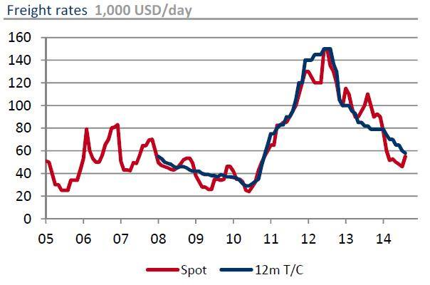

Graph 1. The titles of the figures must be Times New Roman 11 moments, full alignment and the word Figure in bold, italics.

For the tables follow the layout below.

Table 1
-one blank line-
The title of the table should be followed in proper Times New Roman 11-point font
-one blank line followed by the table –

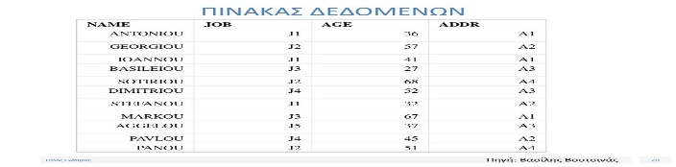

Figures and tables can, if necessary, occupy the entire width of the text area. All figures and tables should be centered and aligned horizontally with respect to the text.

HEADINGS, FOOT PAGE, PAGE NUMBERS
No headers, footers or page numbers should be inserted.

ANNEX
If there is an Appendix, it is listed at the end of the paper after the Bibliography (Times New Roman 11 point font).

BIBLIOGRAPHICAL REFERENCES AND BIBLIOGRAPHY
References should be identified in the text with the author's last name and date, such as (Snow, 2001) or (Kintsch & McNamara, 2009). Citation in parentheses of several researchers should be done with a dot (Snow, 2001; Kintsch & McNamara, 2009).
The bibliography should follow alphabetical order, as in the model listed below. Authors should ensure that all references included in the main text are included in the bibliography and vice versa, and that all bibliographic information is complete, including page numbers. Also, if there are references from the internet, check that the websites are accessible.

INSTRUCTIONS FOR THE SUBMISSION OF THE FINAL TEXTS OF THE PAPERS
Please, the texts should be formatted according to this standard and their submission should be made to the conference email ddeartasynedria@gmail.com

Attention: The file must be MS Word and not PDF.

SAMPLE BIBLIOGRAPHY
Angelidis, P. (2011). The pedagogy of providing equal opportunities. In: P. Angelidis (Ed.), Pedagogies of Inclusion (pp. 43-71). Athens: Interaction.
Darvoudis, A. (2010). Homework and students with learning difficulties (PhD thesis, University of Thessaly). Available from the National Documentation Center database (Ref. 26811). [If accessed via the internet, please provide the website (URL)]
Eysenck, M.W. (2010). Basic principles of cognitive psychology (edited by M. Kouletianou). Athens: Gutenberg.
Francis, D. J., Fletcher, J. M., Catts, H. W., & Tomblin, J. B. (2005). Dimensions affecting the assessment of reading comprehension. In: S. G. Paris & S. A. Stahl (Eds.), Children's Reading Comprehension and Assessment (pp. 369 - 394). Mahwah, NJ: Lawrence Erlbaum Associates.
Koronakis, A. (2016, April). Contemporary forms of leadership promoting inclusive education: the role of the school principal. Announcement at the 1st International Conference "Evaluation in Education: Organization, Administration, Teaching Materials, Analytical Programs", Alexandroupoli. Retrieved September 10, 2020 from http://thraki.inpatra.gr/wp-content/uploads/2016/07/thraki2016final.pdf
McLeskey, J., Waldron, N., & Redd, L. (2014). A case study of a highly effective inclusive elementary school. The Journal of Special Education, 48(1), 59-70.
Penteri, E. (2012). Psychopedagogical dimensions of the family-kindergarten relationship: An investigation of parental involvement and factors influencing it (Unpublished Doctoral Dissertation). Democritus University of Thrace/T.E.P.H., Alexandroupoli.
Saarni, C. (1999). The development of emotional competence. New York: Guilford Press.
Sakulogeorga-Kostaki, K. (2010). The autistic spectrum in the light of cognitive psychology: A review of the contemporary literature. Psychology, 17(1), 89-112.
Swanson, H.L. (1993). Individual Differences in Working Memory: A Model Testing and Subgroup Analysis of Learning-Disabled and Skilled Readers. Intelligence, 17(3), 285-332. doi:10.1016/0160-2896(93)90003-N
Tsagkalidis, G. (2016). School management and inclusion of students with special educational needs or disabilities. (Thesis. University of the Aegean). Retrieved April 23, 2020 from https://hellanicus.lib.aegean.gr/bitstream/handle/11610/2016%29.pdf?sequence=4&isAllowed=y
Tsiantis, G., & Dragona, T. (Eds.) (1999). Babies and mothers. Athens: Kastaniotis.
Flouris, G. (1989). Self-concept, school performance and parental influence. Athens: Grigoris.

